**External Practical Exam**

**Aim:**

Develop a secure and decentralized land registration smart contract that allows:

* The government authority (land registrar) to register land properties.
* Owners to transfer land ownership to other individuals securely.
* LandRegistrar: The government authority that registers land and approves transfers.
* Owner (User): Person who owns a piece of land and can transfer it.
* Buyer/New Owner: A valid Ethereum address to whom land is transferred.

Functional requirements:

* Only the LandRegistrar (contract deployer) can register a new land property.
* Land properties must include: Land ID, Location (string), Current Owner, Area (in square meters),
* Owner of a land can initiate a transfer to another address.
* LandRegistrar must approve the transfer to finalize ownership change.
* System must prevent unauthorized land registration or transfer.

**Code : (LandRegistry.sol)**

// SPDX-License-Identifier: MIT

pragma solidity ^0.8.17;

contract LandRegistry {

    address public landRegistrar;

    event LandRegistered(uint256 landId, string location, address indexed owner, uint256 area);

    event TransferInitiated(uint256 landId, address indexed newOwner);

    event TransferApproved(uint256 landId, address indexed newOwner);

    constructor() {

        landRegistrar = msg.sender;

    }

    struct Land {

        uint256 landId;

        string location;

        address currentOwner;

        uint256 area;

        bool exists;

    }

    struct PendingTransfer {

        address newOwner;

        bool exists;

    }

    mapping(uint256 => Land) public lands;

    mapping(uint256 => PendingTransfer) public pendingTransfers;

    modifier onlyRegistrar() {

        require(msg.sender == landRegistrar, "Only registrar can perform this action");

        _;

    }

    modifier onlyOwner(uint256 landId) {

        require(lands[landId].exists, "Land not found");

        require(msg.sender == lands[landId].currentOwner, "Only the current owner can perform this action");

        _;

    }

    function registerLand(

        uint256 landId,

        string memory location,

        address owner,

        uint256 area

    ) public onlyRegistrar {

        require(!lands[landId].exists, "Land already registered");

        lands[landId] = Land({

            landId: landId,

            location: location,

            currentOwner: owner,

            area: area,

            exists: true

        });

        emit LandRegistered(landId, location, owner, area);

    }

    function initiateTransfer(uint256 landId, address newOwner) public onlyOwner(landId) {

        require(newOwner != address(0), "Invalid address");

        pendingTransfers[landId] = PendingTransfer({newOwner: newOwner, exists: true});

        emit TransferInitiated(landId, newOwner);

    }

    function approveTransfer(uint256 landId) public onlyRegistrar {

        require(pendingTransfers[landId].exists, "No transfer initiated");

        lands[landId].currentOwner = pendingTransfers[landId].newOwner;

        delete pendingTransfers[landId];

        emit TransferApproved(landId, lands[landId].currentOwner);

    }

    function getLandDetails(uint256 landId) public view returns (string memory location, address currentOwner, uint256 area) {

        require(lands[landId].exists, "Land not found");

        Land memory land = lands[landId];

        return (land.location, land.currentOwner, land.area);

    }

}

**Output:**

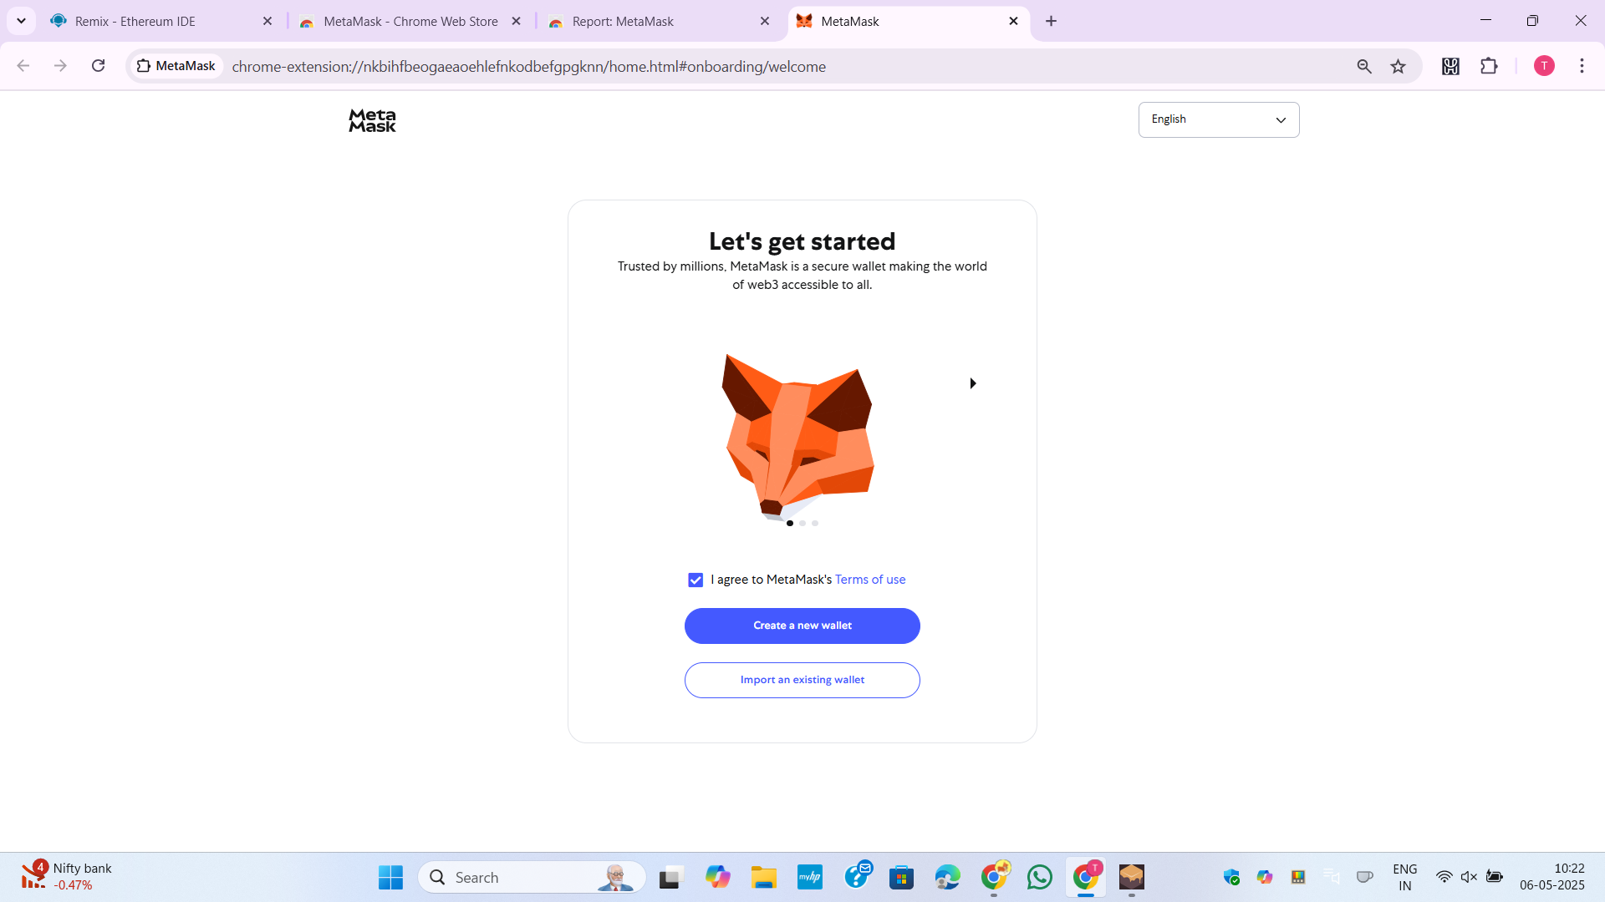

Figure 1:Install MetaMask

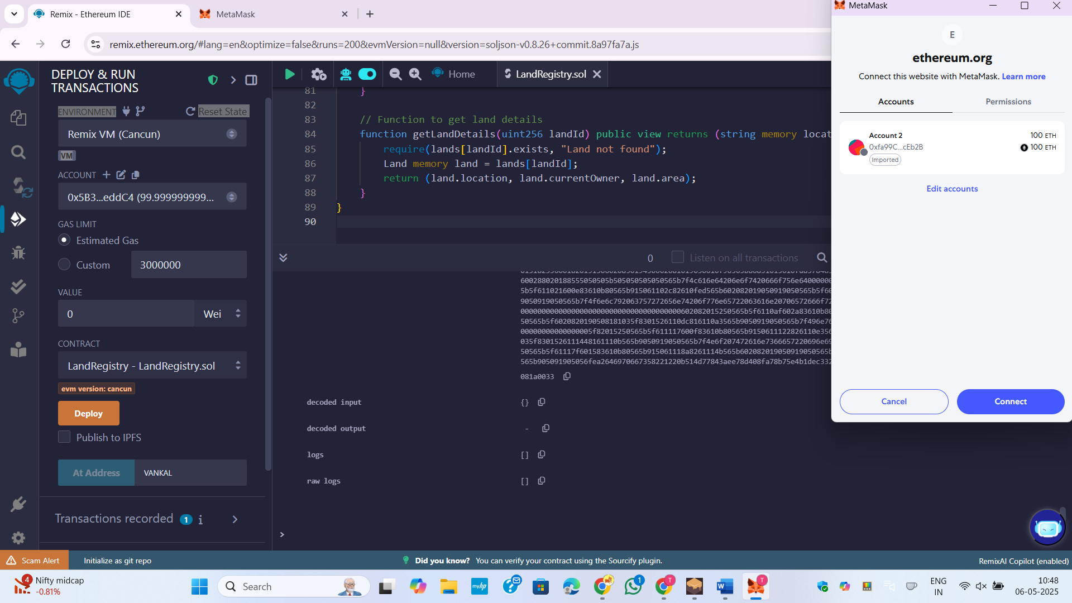

Figure 2:Connect REMIX IDE with MetaMask

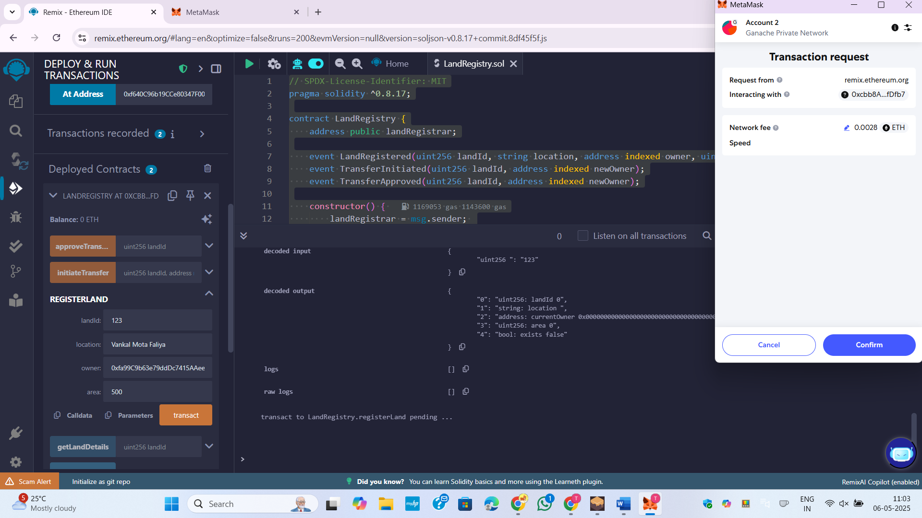

Figure 3:Register land with landid = 123

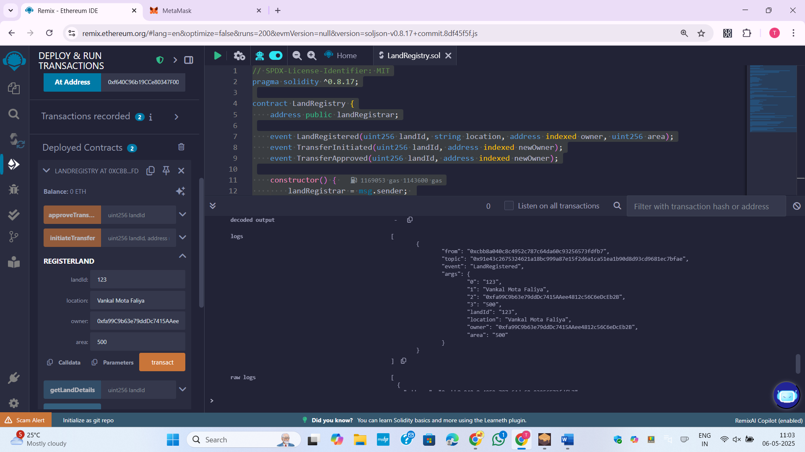

Figure 4:Log of Land Registration

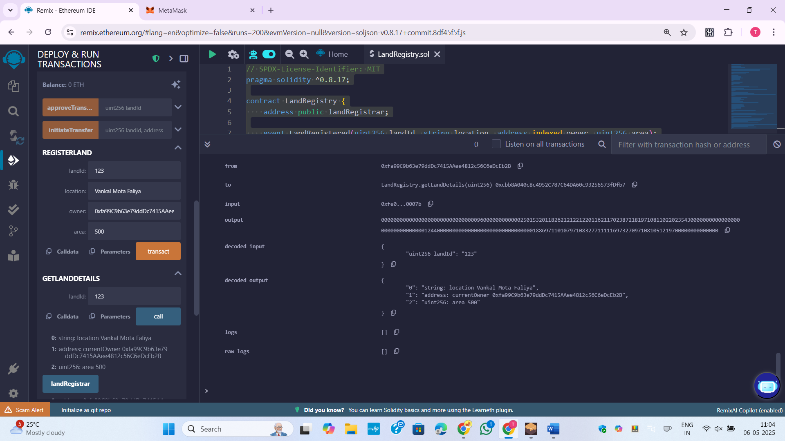

Figure 5:Fetch Land Details

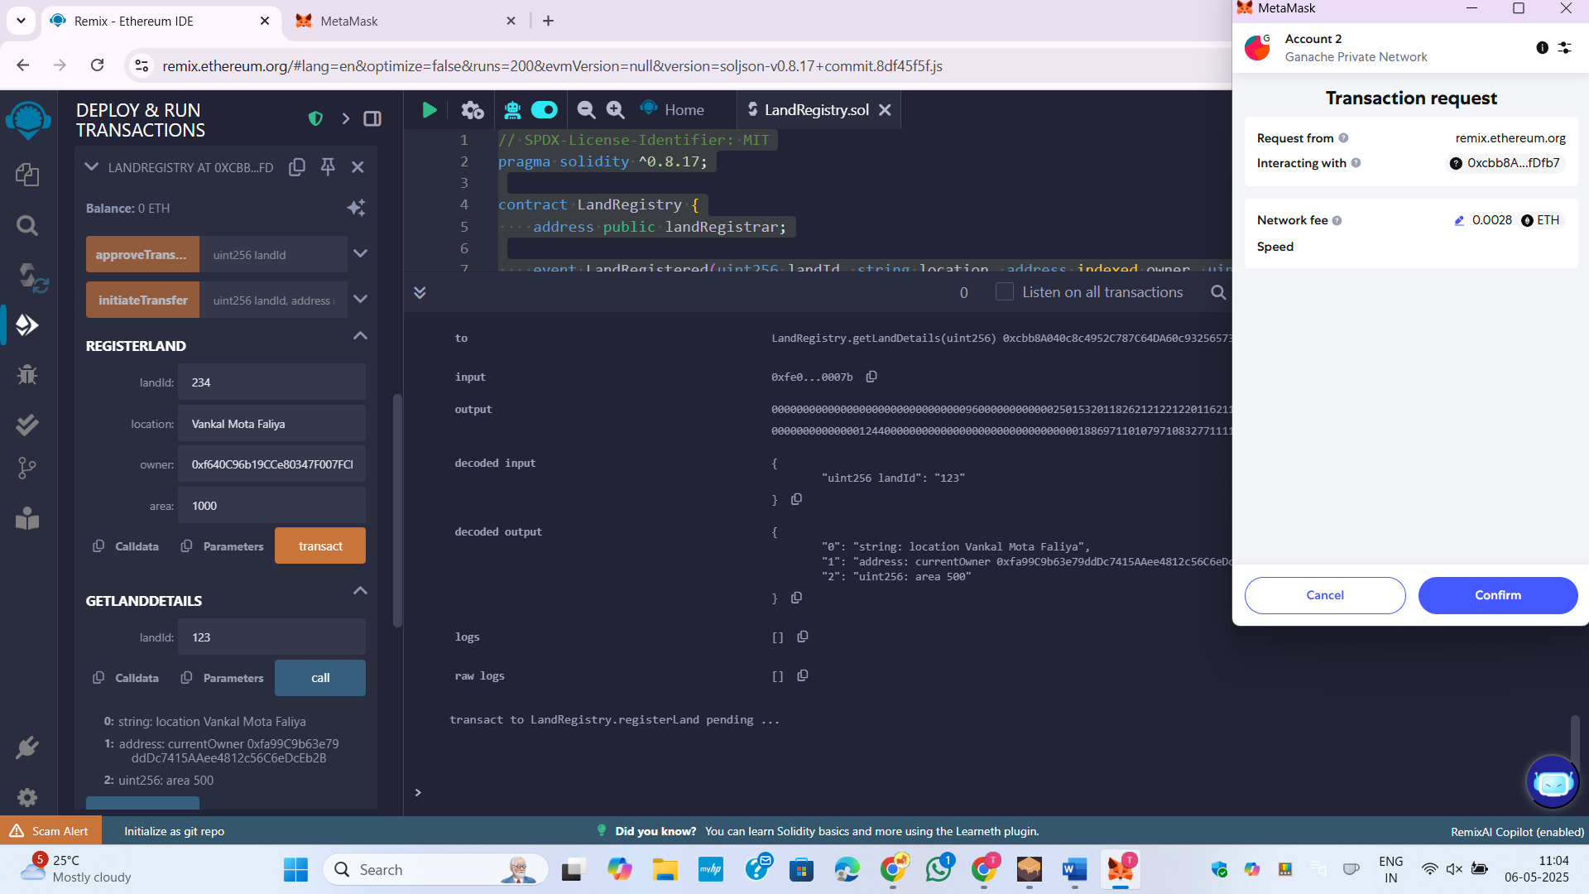

Figure 6:Add new Land Details

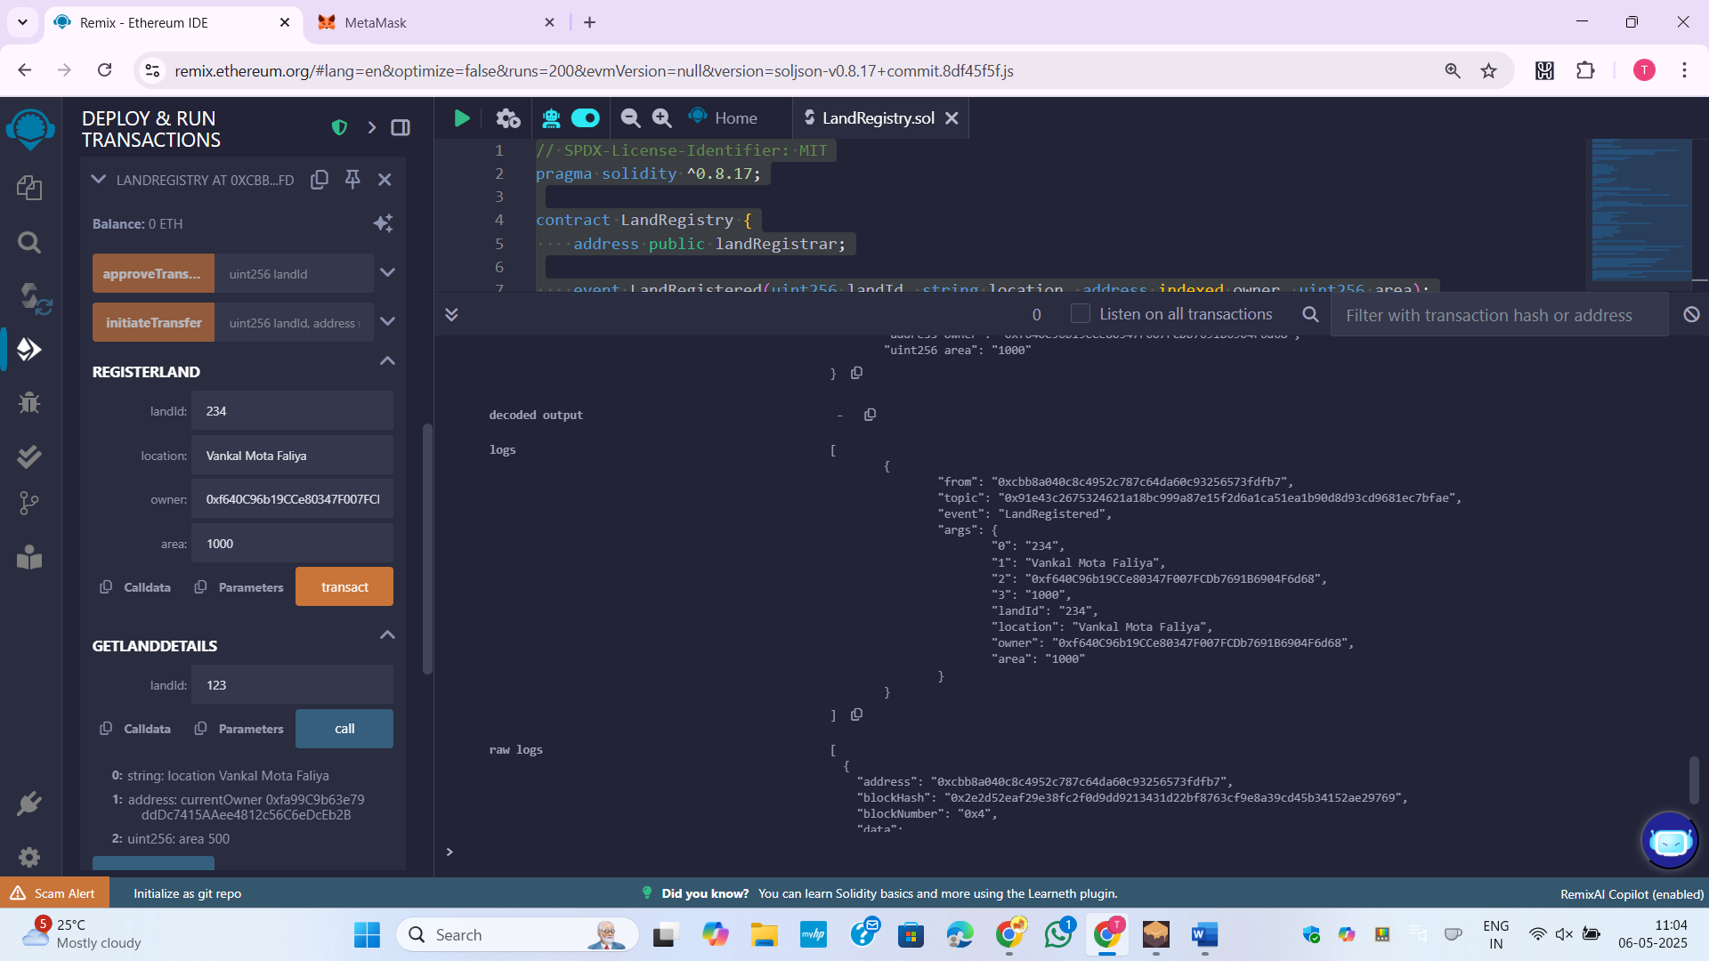

Figure 7:Land Details where landid=234

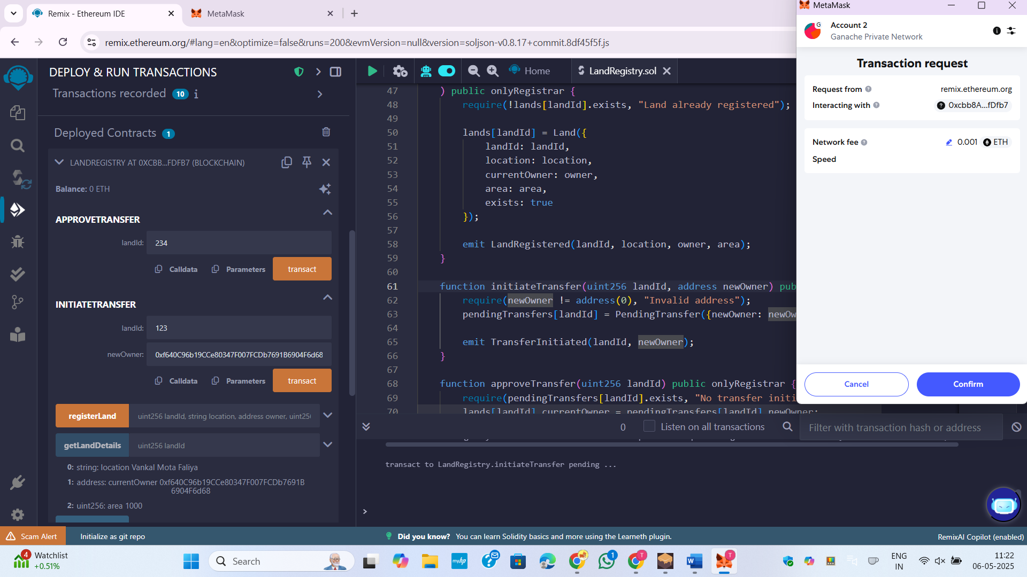

Figure 8:Ask metamak for transaction

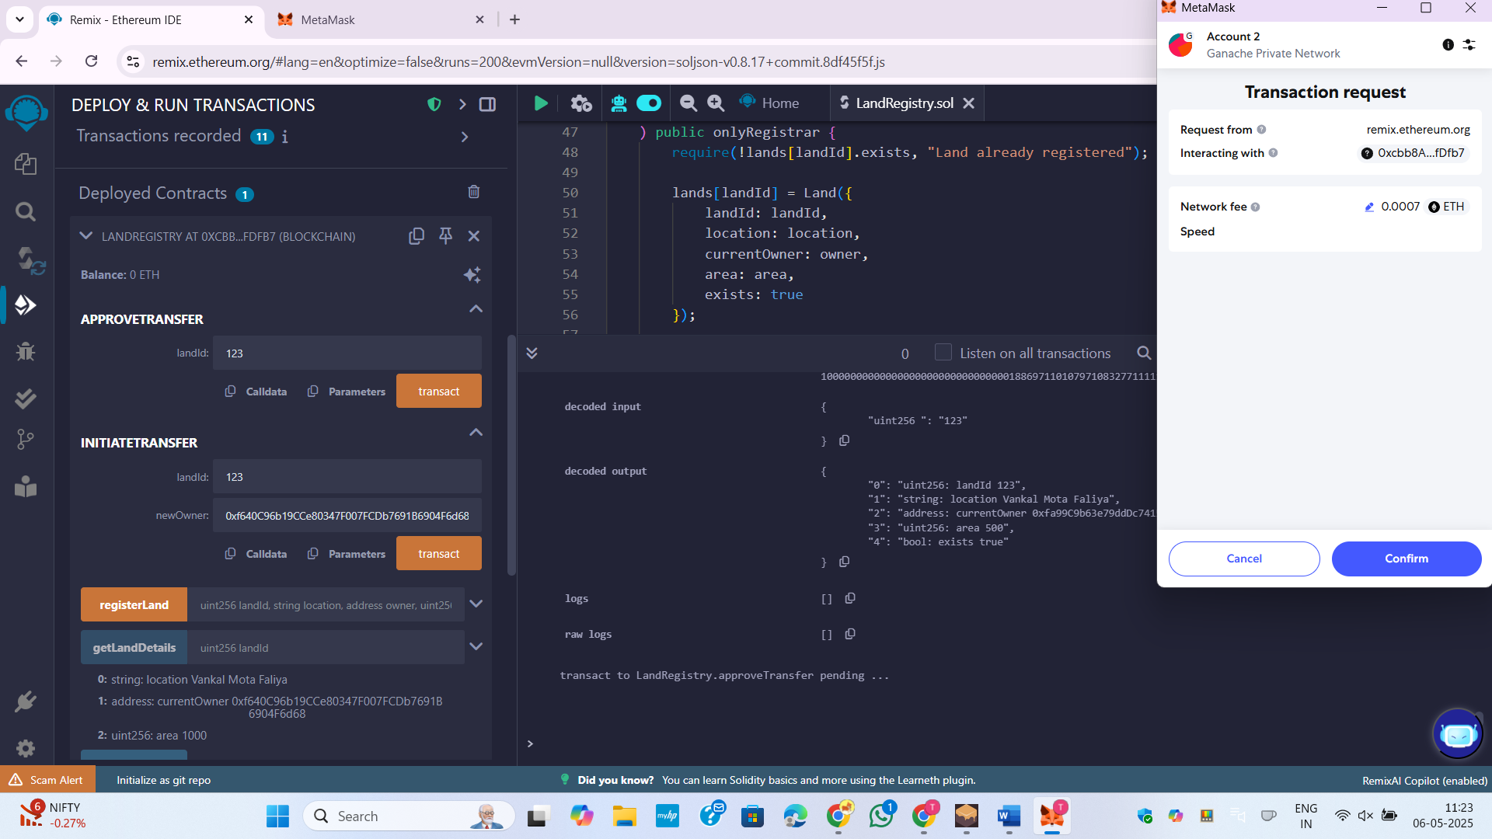

Figure 9:Approve the transaction for Land 123

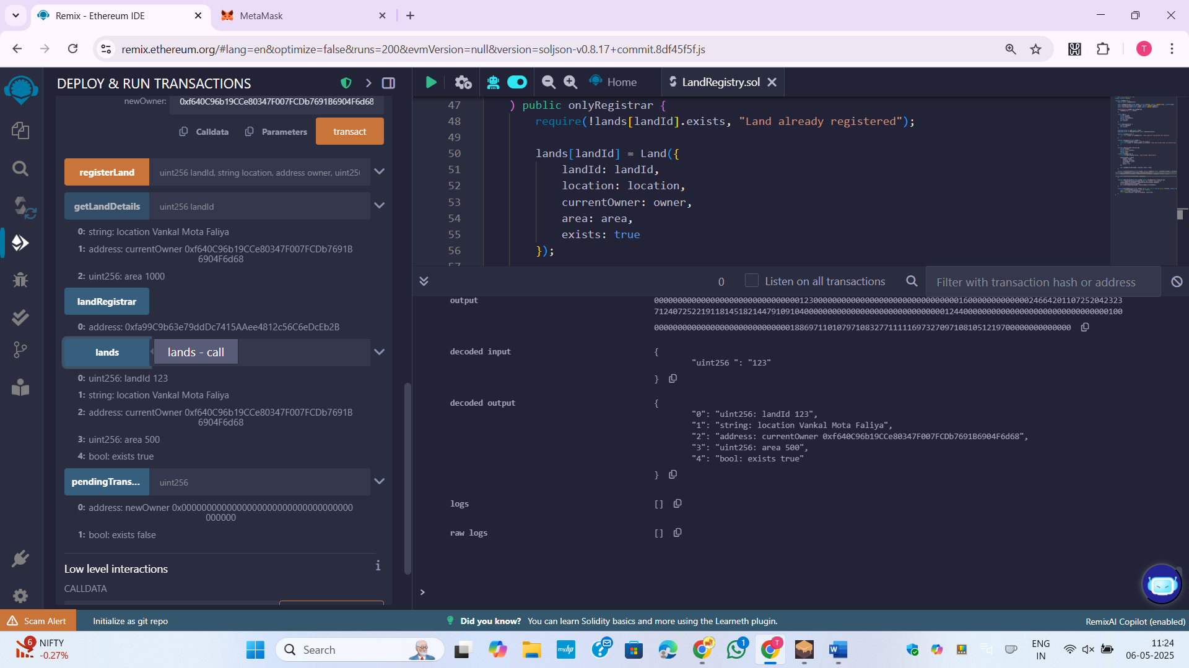

Figure 10:New Owner Change for landid 123

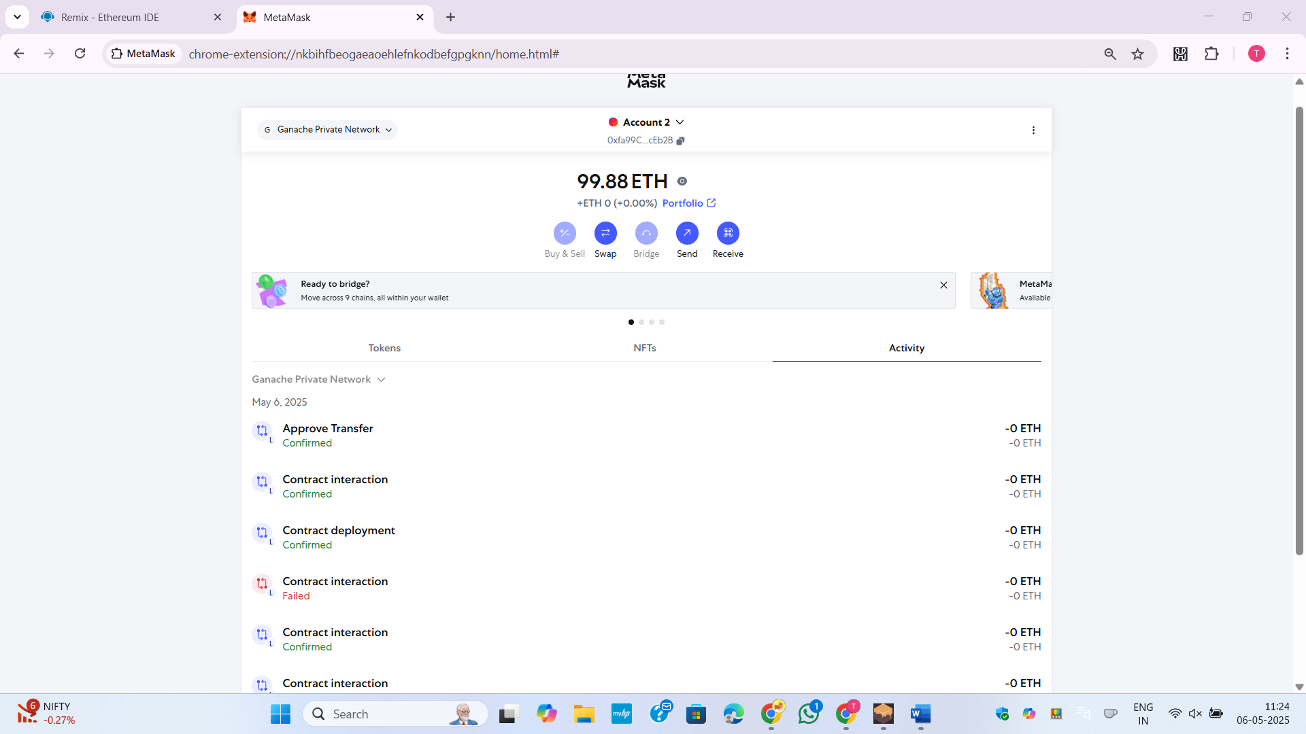

Figure 11:Transaction in MetaMask

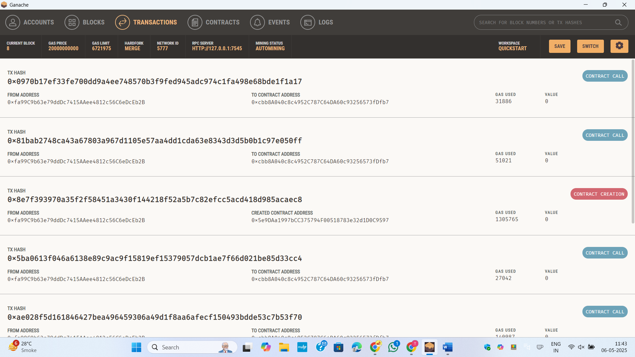

Figure 12:Transaction Ganache

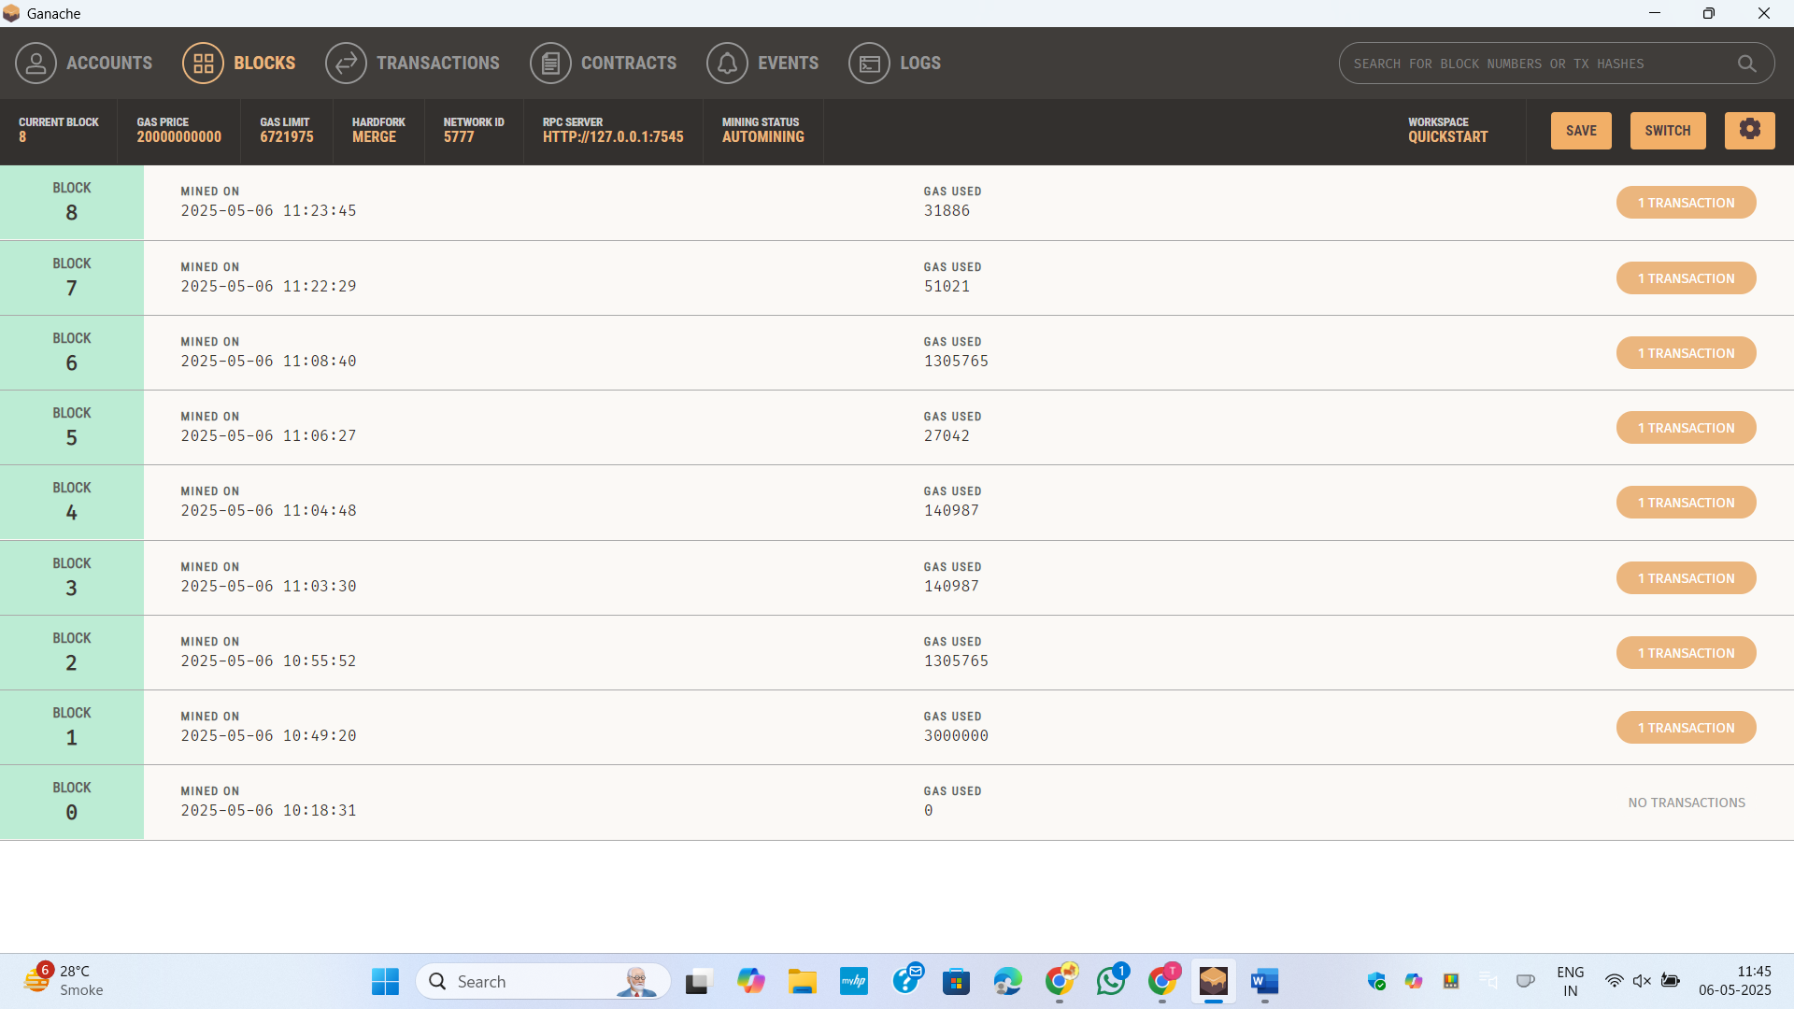

Figure 13:Trasaction block in Ganache

**AIM:**

Develop a decentralized smart contract system to manage patient medical records on the Ethereum blockchain. The contract should allow doctors to create records, patients to access them, and administrators to manage permissions.

* Admin (Hospital or Health Authority): Deployer of the contract, manages doctor and patient
* registration.
* Doctor: Authorized to create and update medical records.
* Patients: Can view their own medical records only.

Functional requirements:

* The admin can register new doctors and patients.
* Only authorized doctors can add or update a patient’s medical record.
* Only registered patients can view their own records.
* A medical record should contain: Patient ID (address), Doctor ID (address), Diagnosis (string),
* Prescription (string), Timestamp
* Ensure access control so that no unauthorized access or modification occurs.

**Code:**

// SPDX-License-Identifier: MIT

pragma solidity ^0.8.17;

contract MedicalRecordSystem {

    address public admin;

    struct MedicalRecord {

        address doctorId;

        string diagnosis;

        string prescription;

        uint256 timestamp;

    }

    mapping(address => bool) public doctors;

    mapping(address => bool) public patients;

    mapping(address => MedicalRecord[]) public records;

    event DoctorRegistered(address indexed doctor);

    event PatientRegistered(address indexed patient);

    event MedicalRecordCreated(address indexed patient, address indexed doctor, string diagnosis, string prescription, uint256 timestamp);

    event MedicalRecordUpdated(address indexed patient, address indexed doctor, string diagnosis, string prescription, uint256 timestamp);

    modifier onlyAdmin() {

        require(msg.sender == admin, "Only admin can perform this action");

        _;

    }

    modifier onlyDoctor() {

        require(doctors[msg.sender] == true, "Only authorized doctors can perform this action");

        _;

    }

    modifier onlyPatient(address patient) {

        require(patients[patient] == true, "Only registered patients can view records");

        _;

    }

    constructor() {

        admin = msg.sender;

    }

    function registerDoctor(address doctor) public onlyAdmin {

        require(doctors[doctor] == false, "Doctor already registered");

        doctors[doctor] = true;

        emit DoctorRegistered(doctor);

    }

    function registerPatient(address patient) public onlyAdmin {

        require(patients[patient] == false, "Patient already registered");

        patients[patient] = true;

        emit PatientRegistered(patient);

    }

    function createMedicalRecord(address patient, string memory diagnosis, string memory prescription) public onlyDoctor {

        require(patients[patient] == true, "Patient not registered");

        MedicalRecord memory newRecord = MedicalRecord({

            doctorId: msg.sender,

            diagnosis: diagnosis,

            prescription: prescription,

            timestamp: block.timestamp

        });

        records[patient].push(newRecord);

        emit MedicalRecordCreated(patient, msg.sender, diagnosis, prescription, block.timestamp);

    }

    function updateMedicalRecord(address patient, uint256 recordIndex, string memory diagnosis, string memory prescription) public onlyDoctor {

        require(patients[patient] == true, "Patient not registered");

        require(records[patient].length > recordIndex, "Invalid record index");

        MedicalRecord storage record = records[patient][recordIndex];

        record.diagnosis = diagnosis;

        record.prescription = prescription;

        record.timestamp = block.timestamp;

        emit MedicalRecordUpdated(patient, msg.sender, diagnosis, prescription, block.timestamp);

    }

    function viewMedicalRecords() public view onlyPatient(msg.sender) returns (MedicalRecord[] memory) {

        return records[msg.sender];

    }

    function isDoctor(address doctor) public view returns (bool) {

        return doctors[doctor];

    }

    function isPatient(address patient) public view returns (bool) {

        return patients[patient];

    }

}

**Output :**

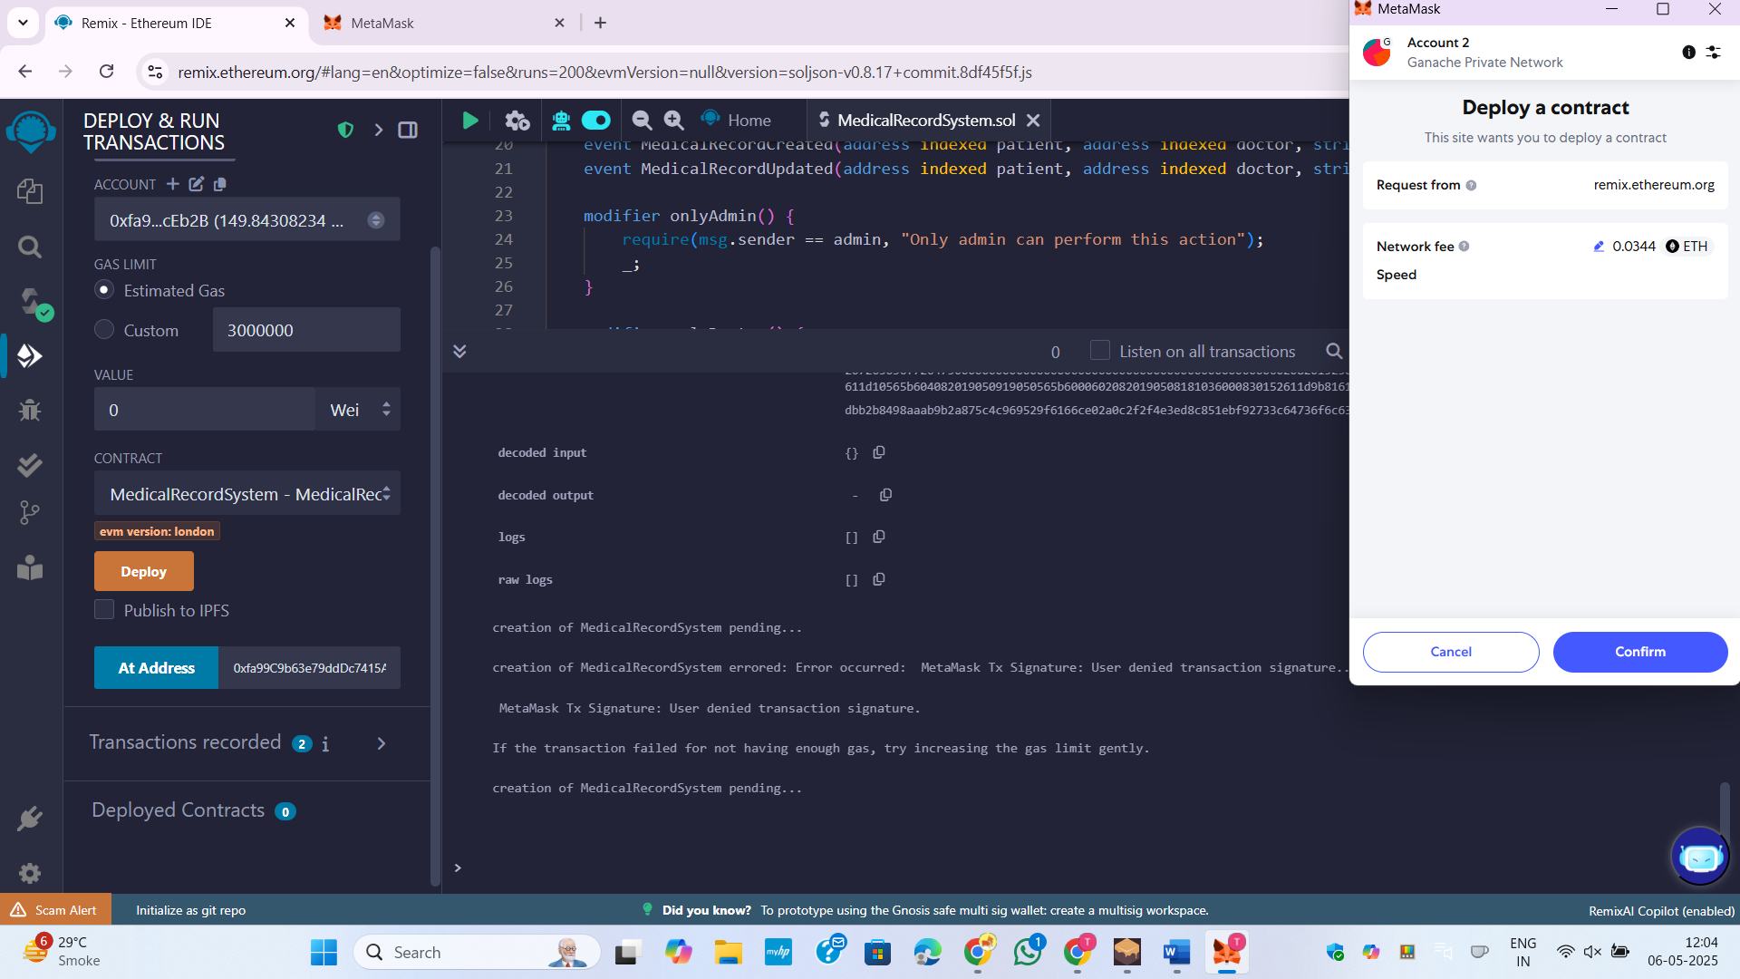

Figure 14:Deploy the contract

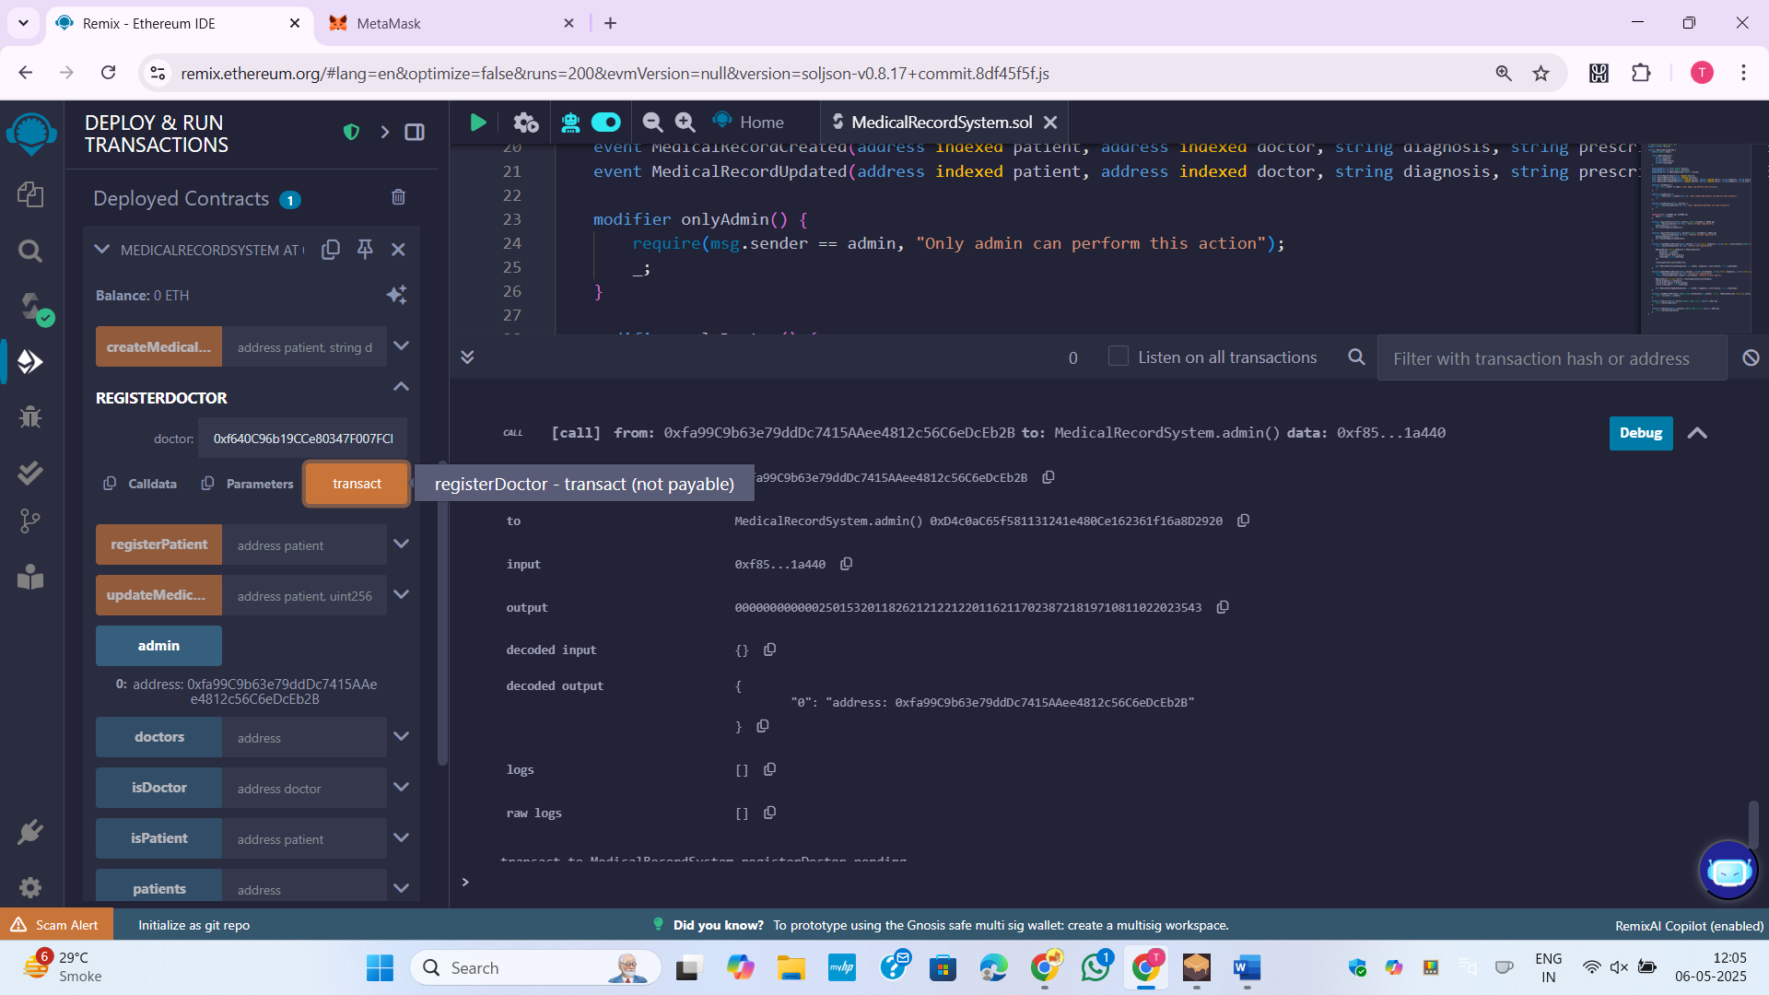

Figure 15:Get Admin details

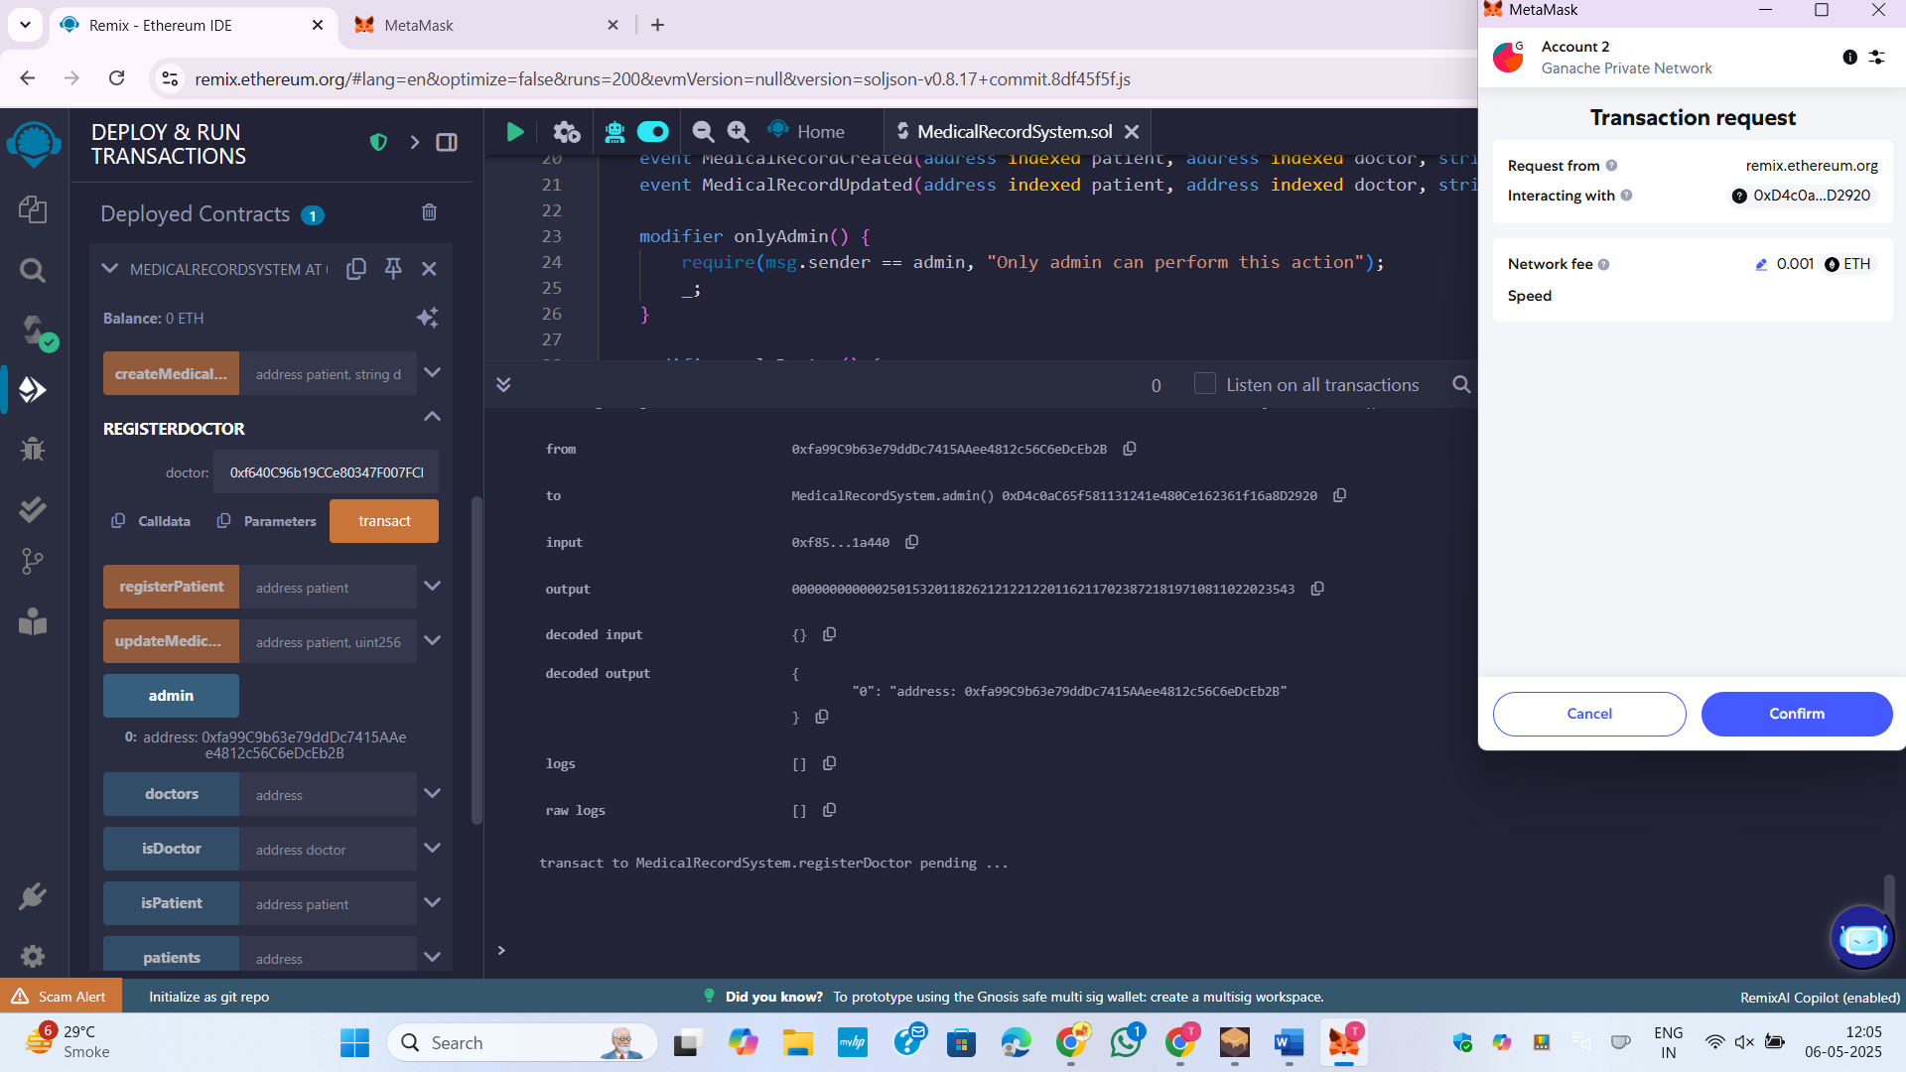

Figure 16:Admin register the Docter

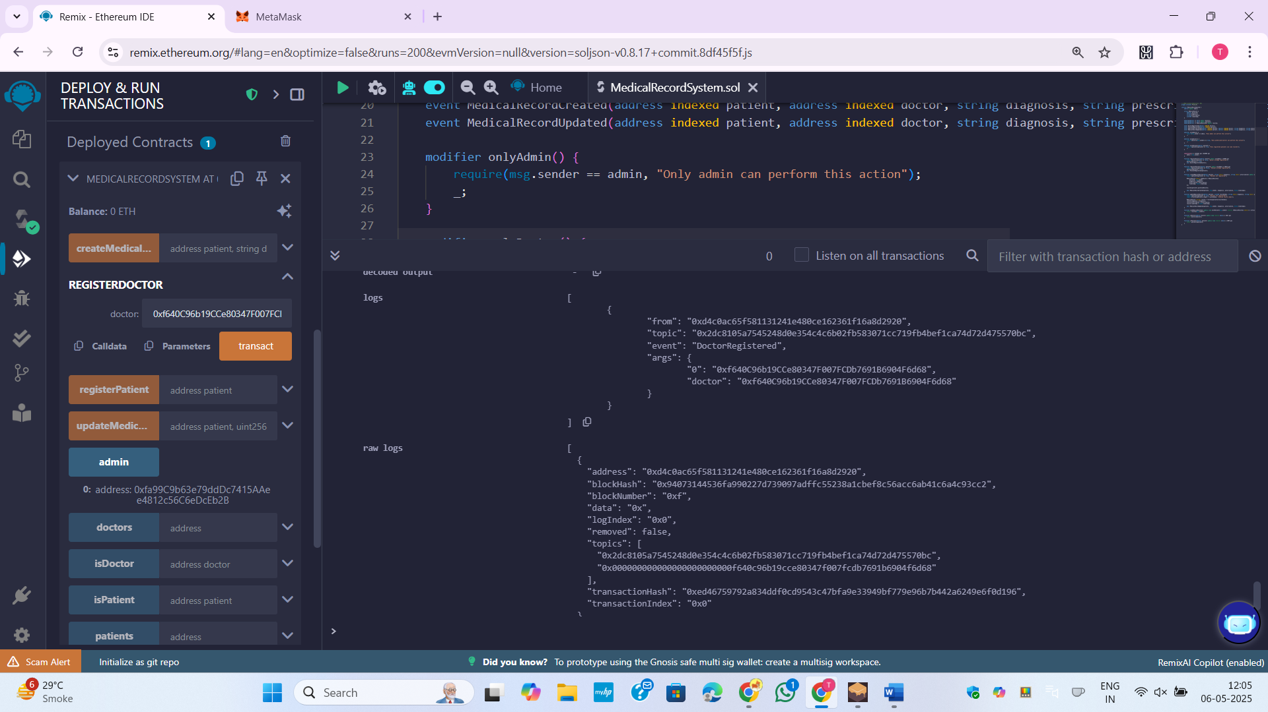

Figure 17:Registration of Docter successfully completed

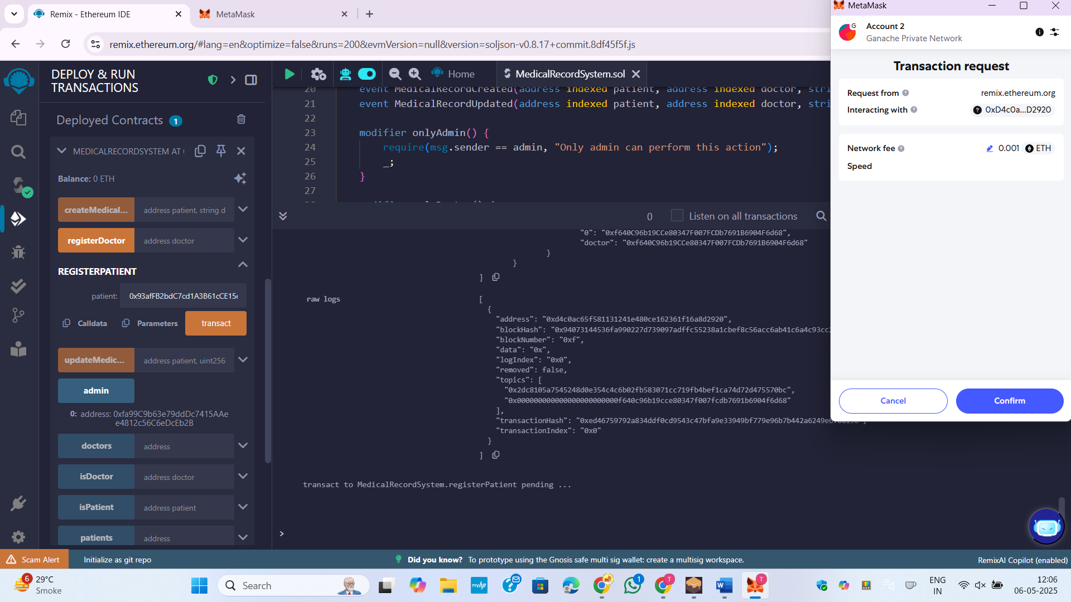

Figure 18:Registration of patient

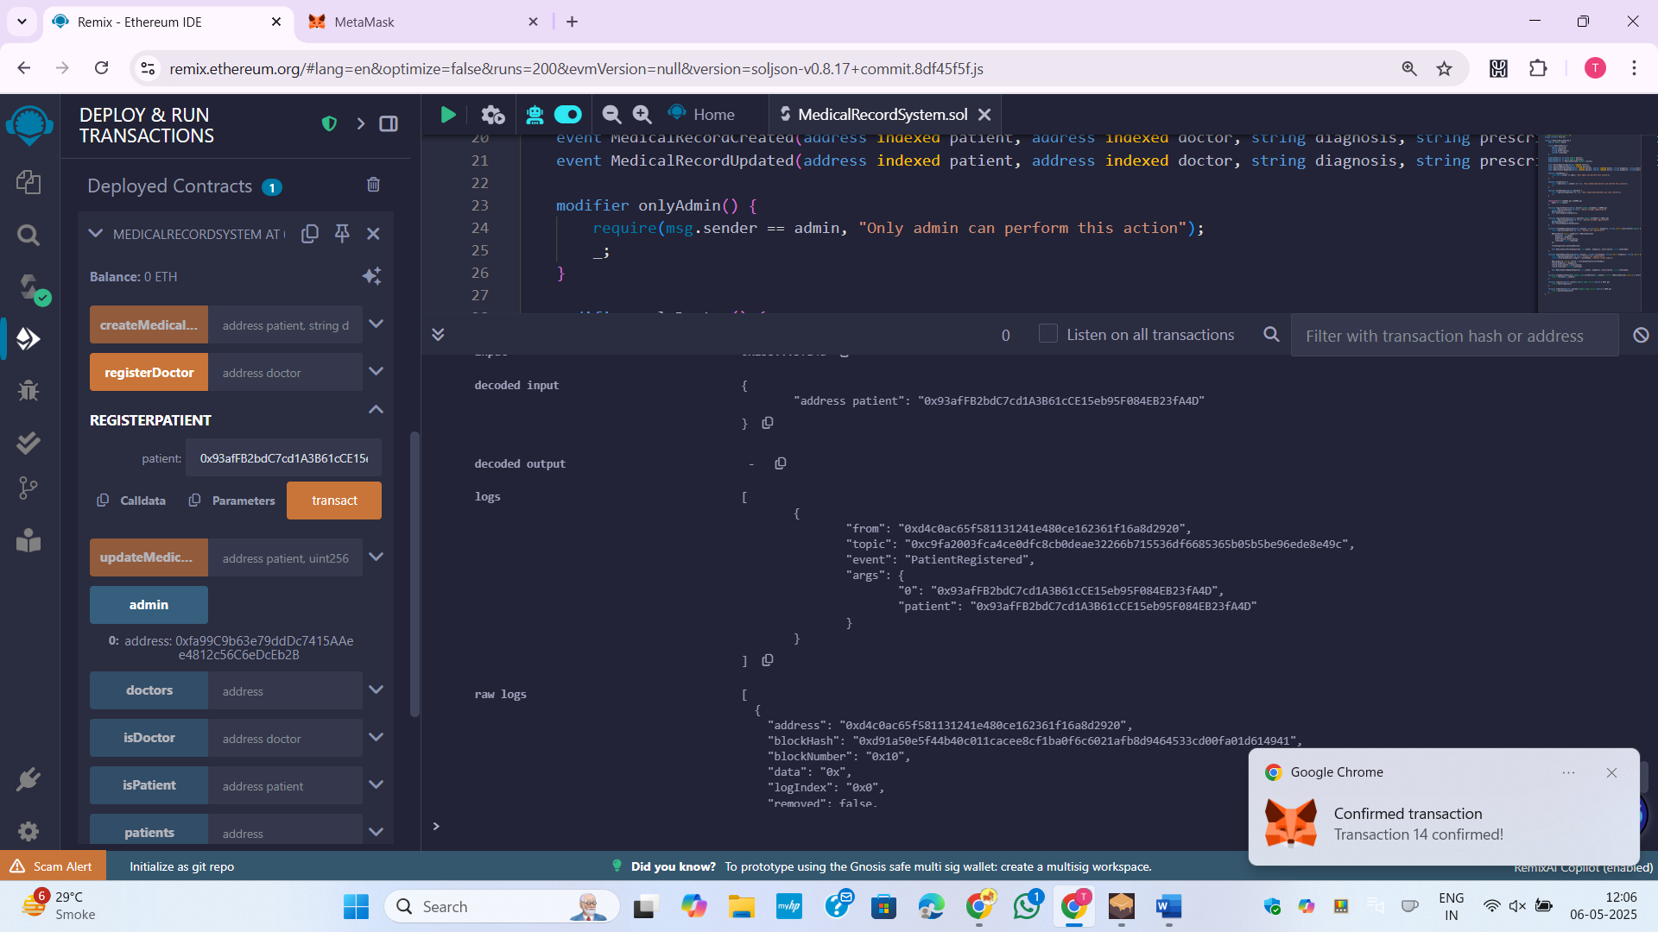

Figure 19:Transaction completed for Registration of patient

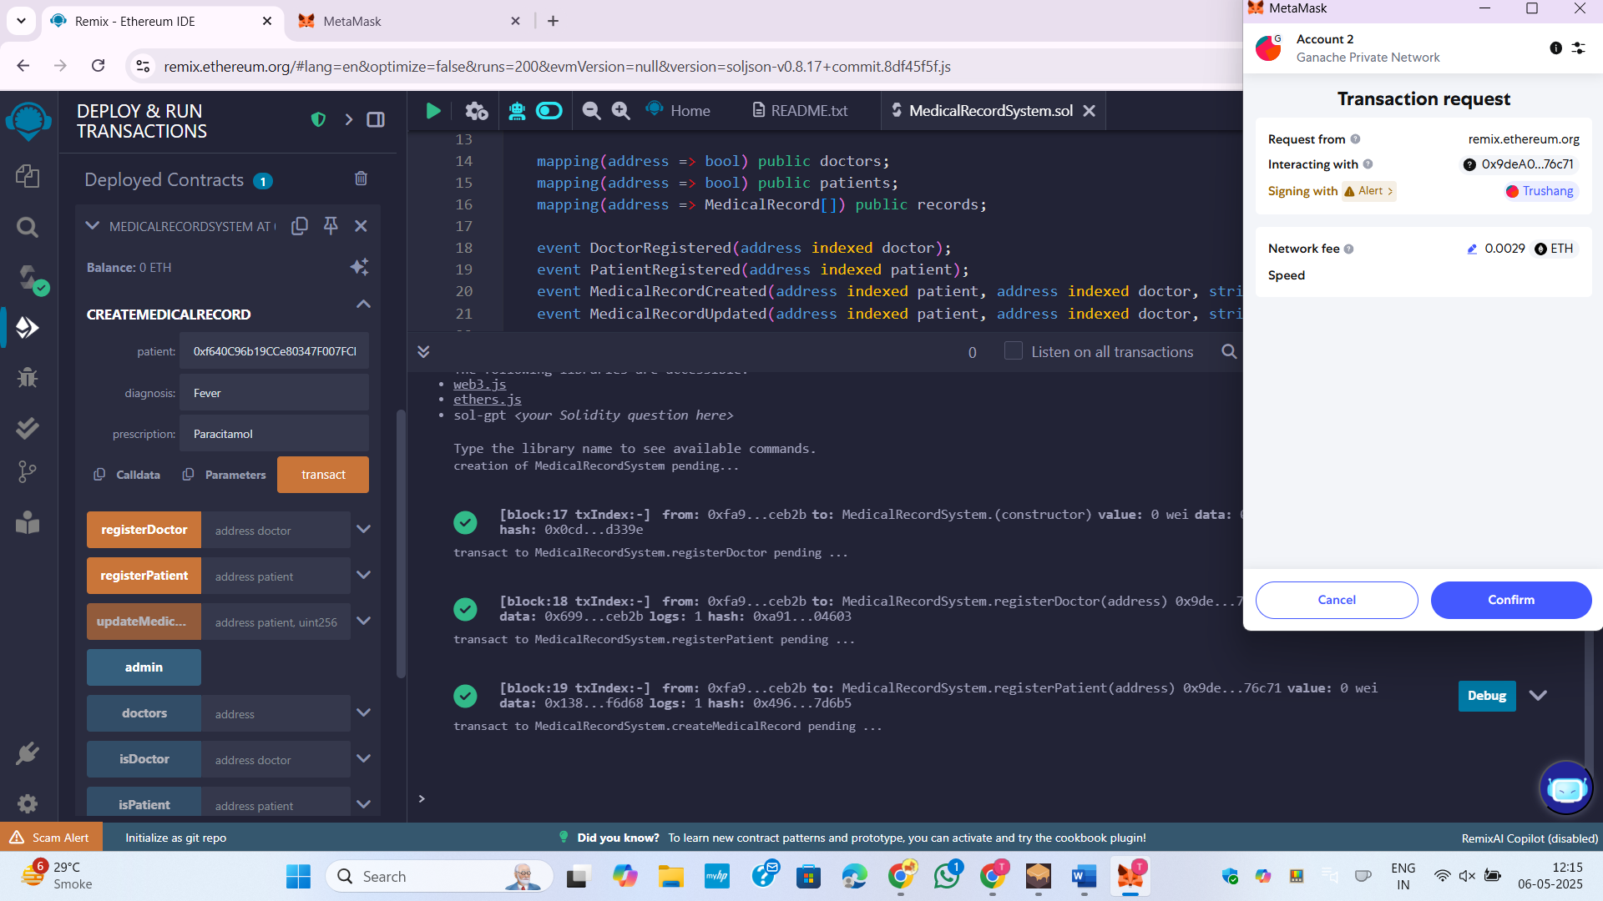

Figure 20:Docter Adding patient details

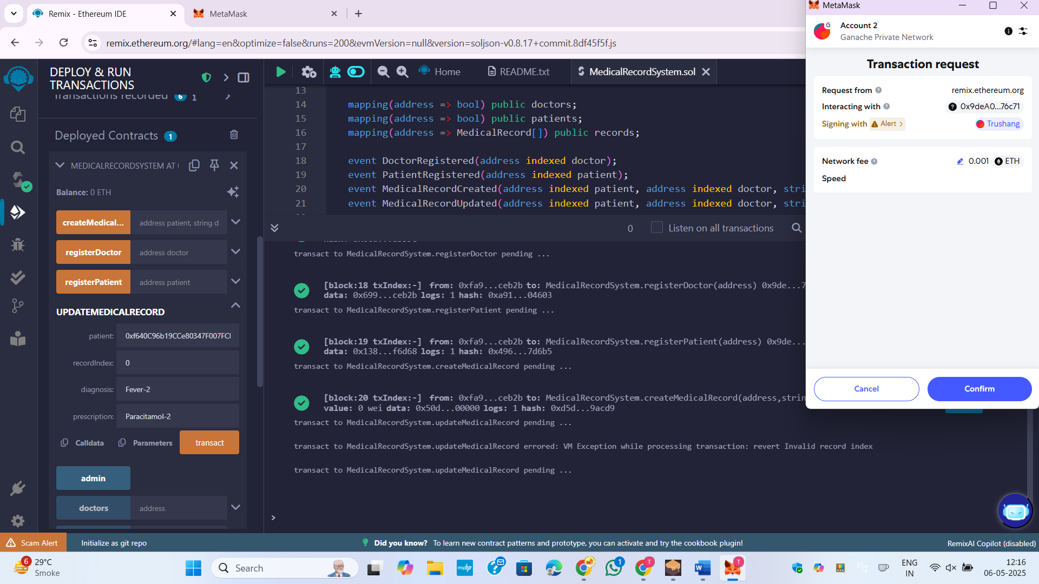

Figure 21:Update patient details

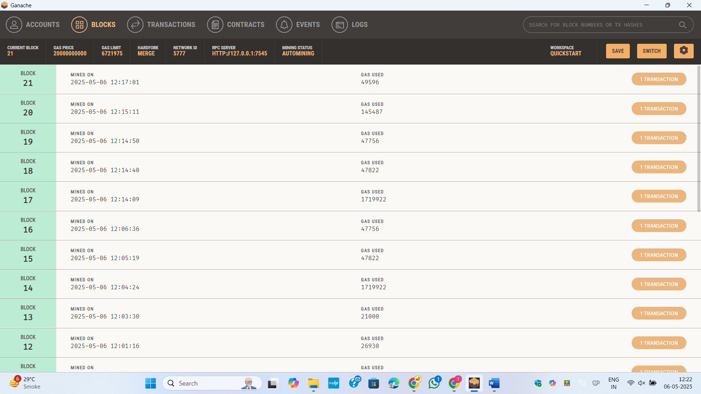

Figure 22:Ganache blocks

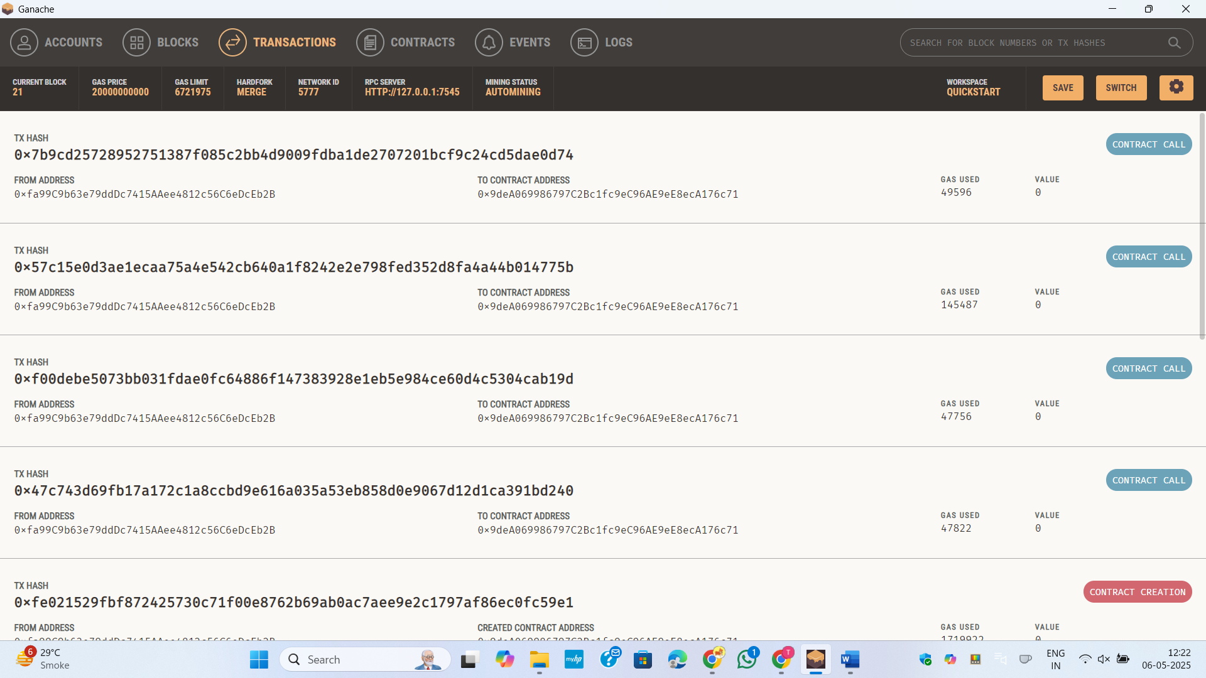

Figure 23:Ganache transaction

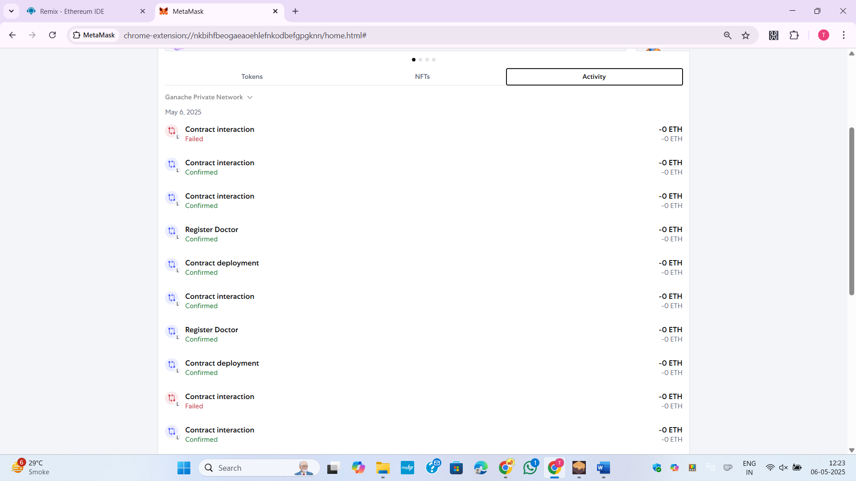

Figure 24:MetaMask Transaction